Table of Contents

1. Main Board 2

1.1. Schematic 2

1.2. Solder MB Bat connector 3

1.3. Solder CPU board & I2C Expanders connectors 3

1.4. Solder Capacitors and Resistors 4

1.5. Solder all connectors on back side except I2S #1, I2S #2 , EXT IO 5

1.6. Straighten and cut pins I2C expanders U3 & U4. Insert I2C expanders. 5

1.7. Install 9mm plastic stands + plastic washer for CPU board 7

1.8. Remove battery holder from CPU board 7

1.9. Solder + and – wires to CPU board and install 2 pin power connector. 7

1.10. Insert CPU board & 2 pin power connector to main board 8

1.11. Solder U4 MAX98357 I2S 8

2. Periphery 9

2.1. Solder Battery Charger and Glue it on adapter. 9

2.2. Solder Power switch 10

2.3. Solder OLED screen 10

2.4. Attach Green button 11

2.5. Solder Red & Blue LED buttons 11

2.6. Solder Switch 11

2.7. 7-Segment Displays RED & BLUE 12

2.8. Neopixels 13

2.9. Keypad 13

2.10. Battery Holder 14

3. Top Panel 14

3.1. Cut top panel from ¼” dark brown Plexiglas 14

3.2. Paint backside 15

3.3. Color the On and Off signs 15

3.4. Attach spacers to periphery 16

3.5. Attach periphery to Top Panel 17

3.6. Attach Main Board 21

# Main Board

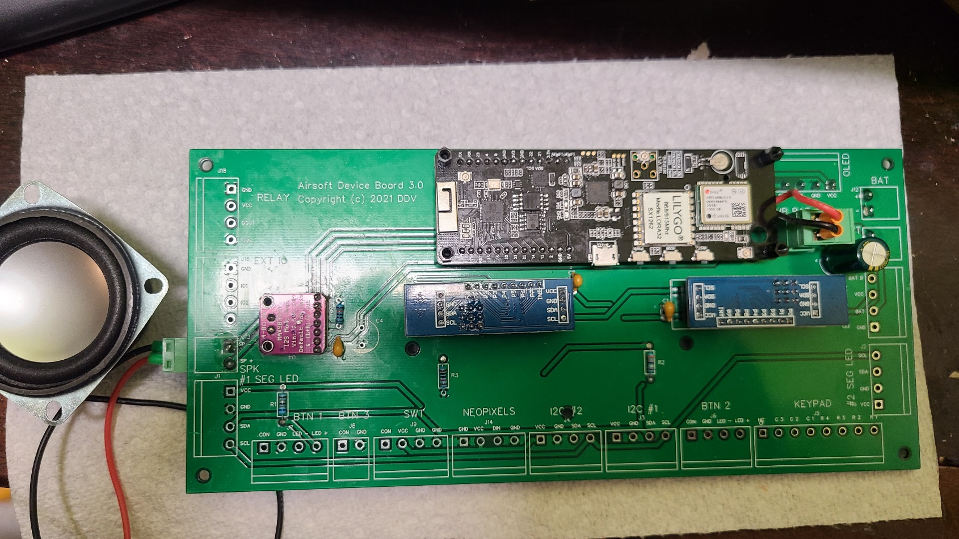

## Schematic

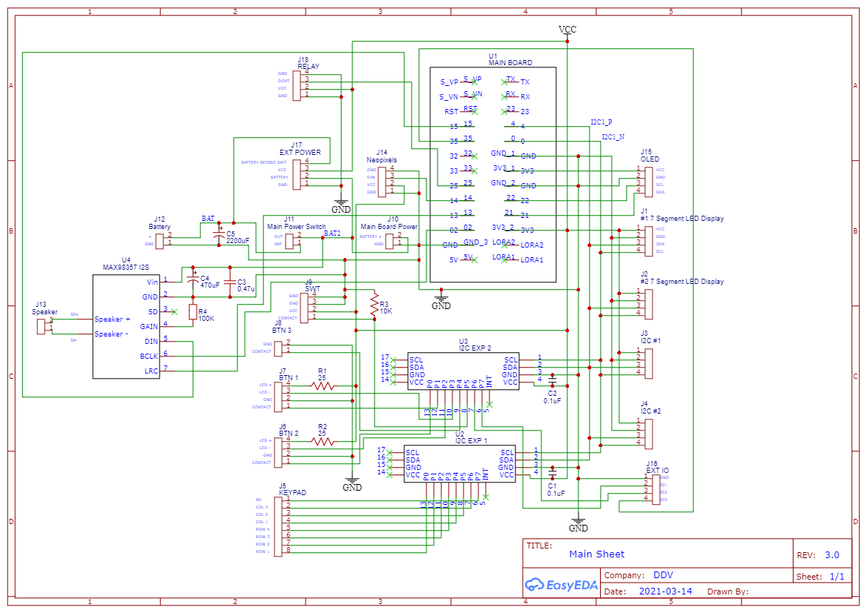

## Solder MB Bat connector

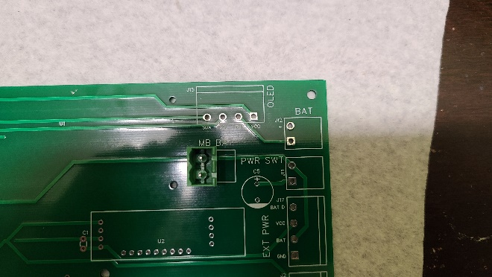

## Solder CPU board & I2C Expanders connectors

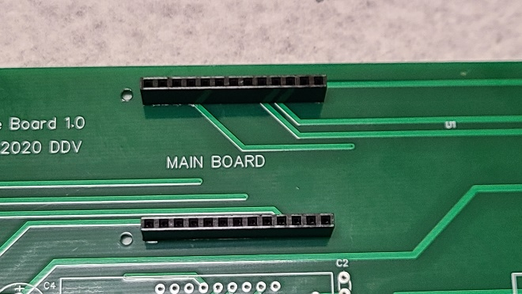

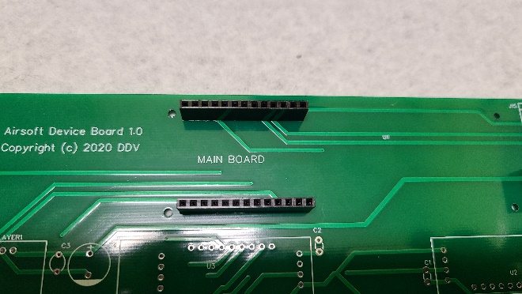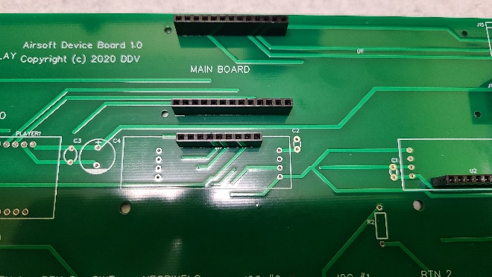

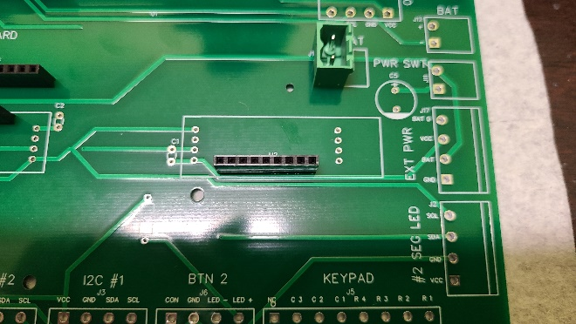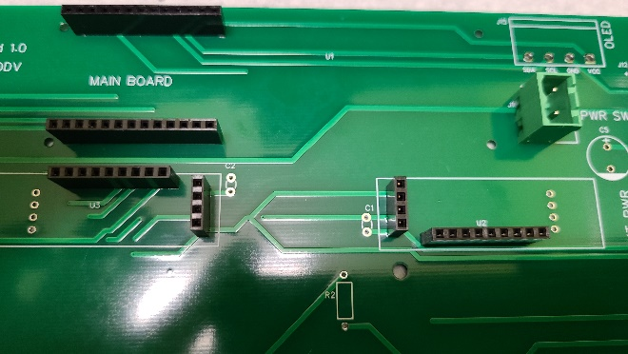

## Solder Capacitors and Resistors

C1, C2, C3 - 474, C5 - 2200u. DO NOT INSTALL C4

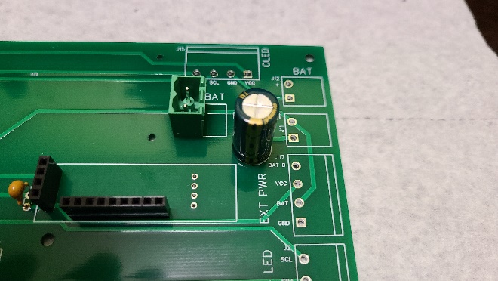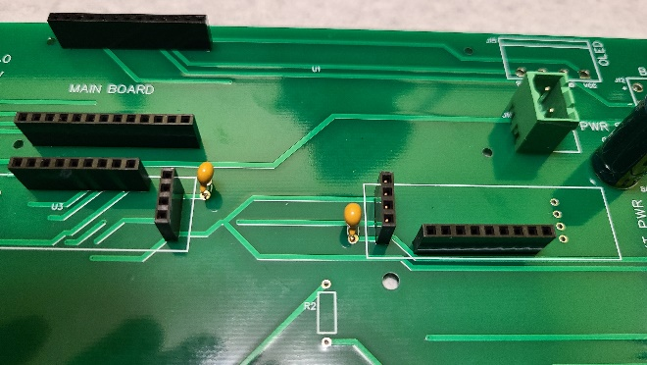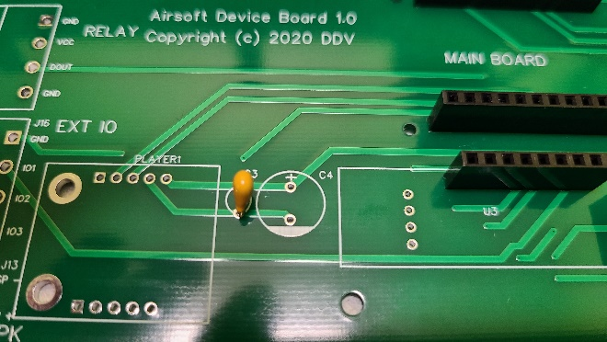

R1 (Red LED 2V) – 75 Ohm, R2 (Blue LED 3V) – 15 Ohm, R3-10K

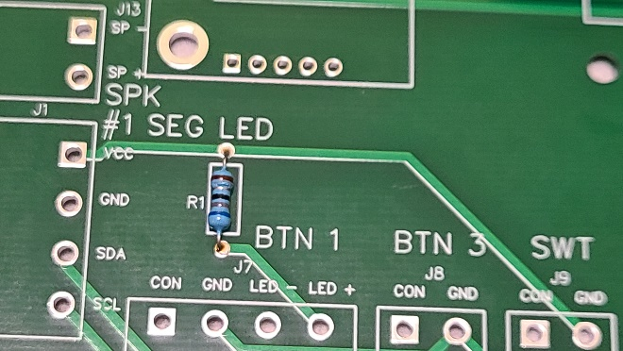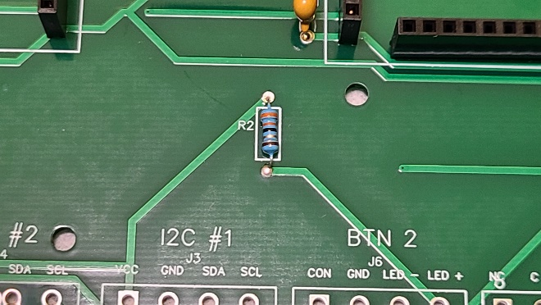

## Solder all connectors on back side except I2S #1, I2S #2 , EXT IO

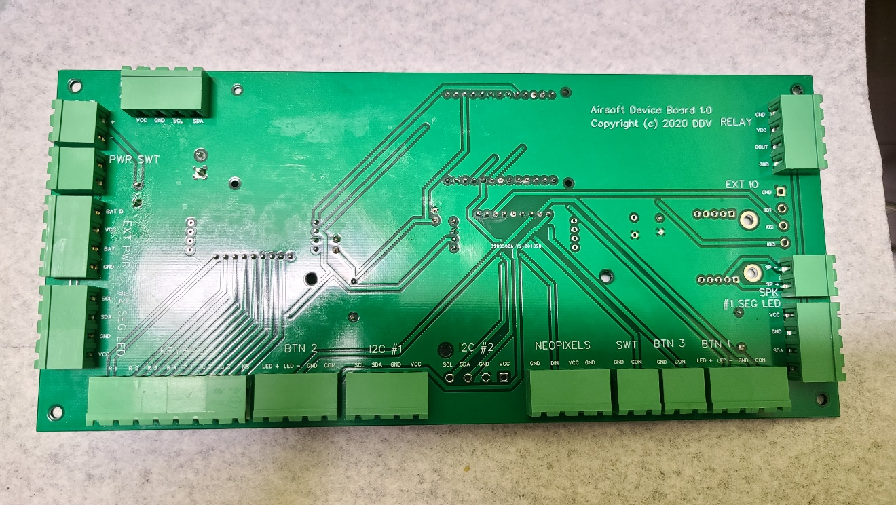

## Straighten and cut pins I2C expanders U3 & U4. Insert I2C expanders.

Solder A0 jumper on U3 I2C expander

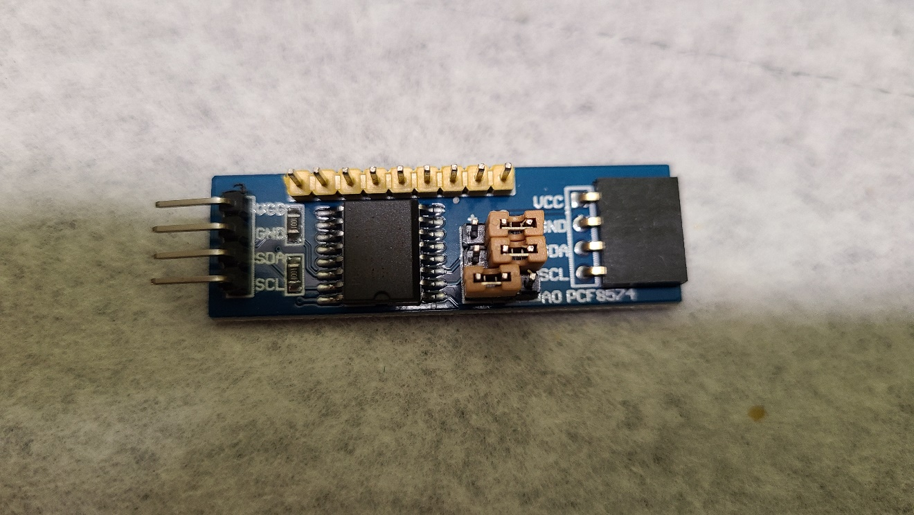

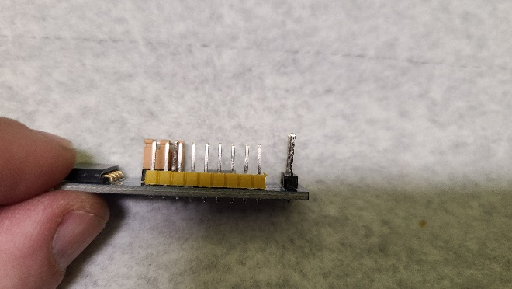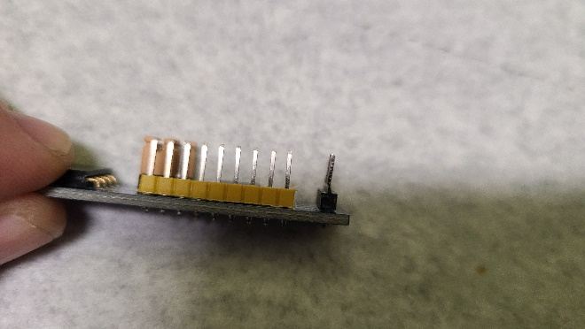

Insert I2C expanders to main board.

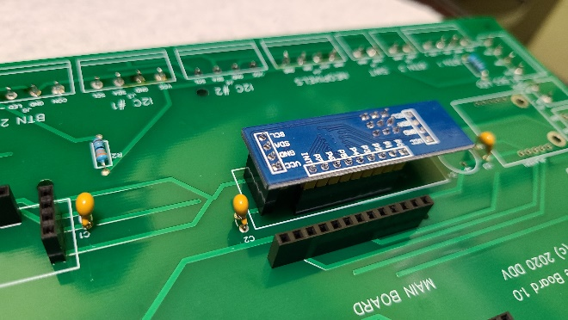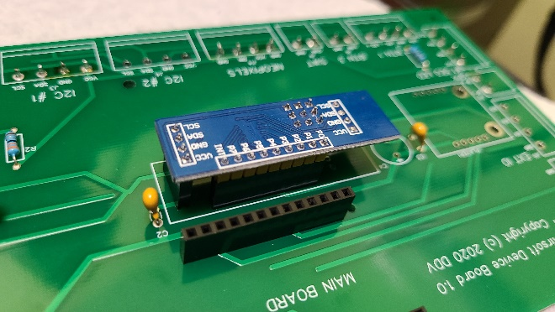

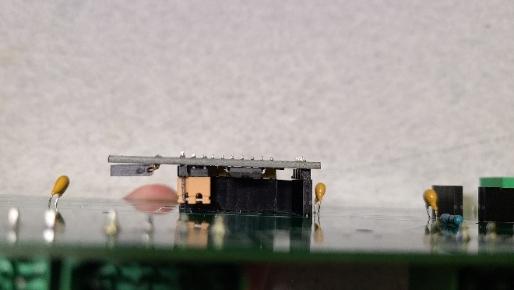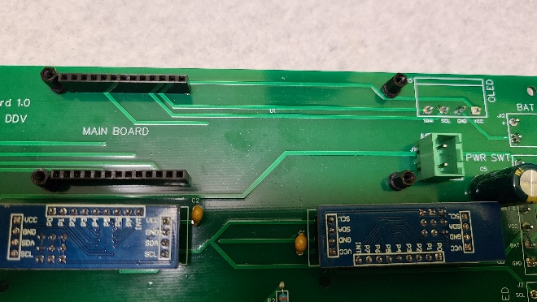

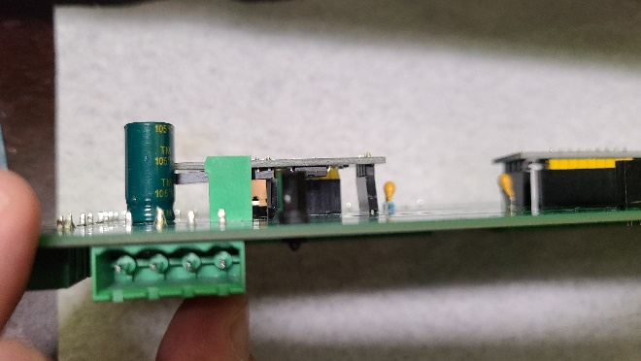

## Install 9mm plastic stands + plastic washer for CPU board

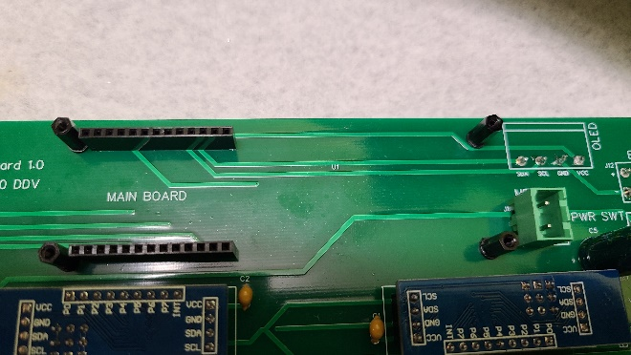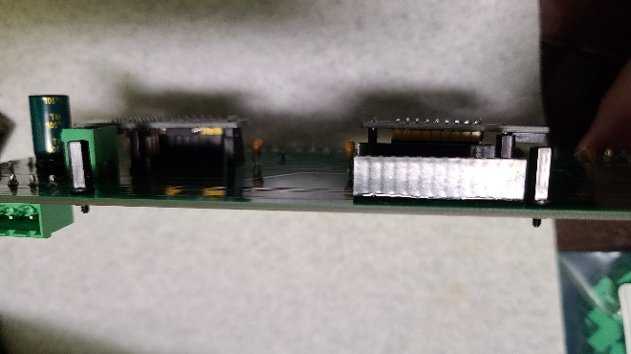

## Remove battery holder from CPU board

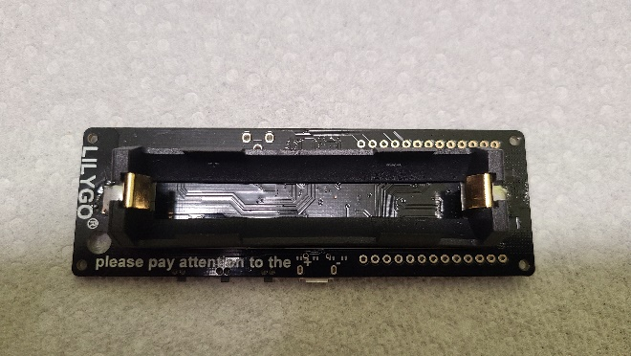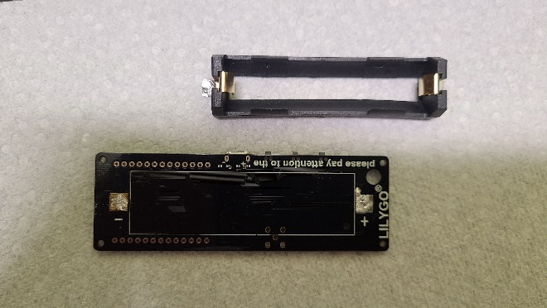

## Solder + and – wires to CPU board and install 2 pin power connector.

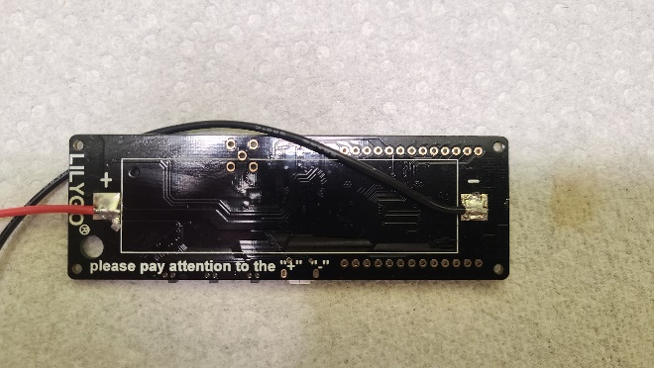

## Insert CPU board & 2 pin power connector to main board

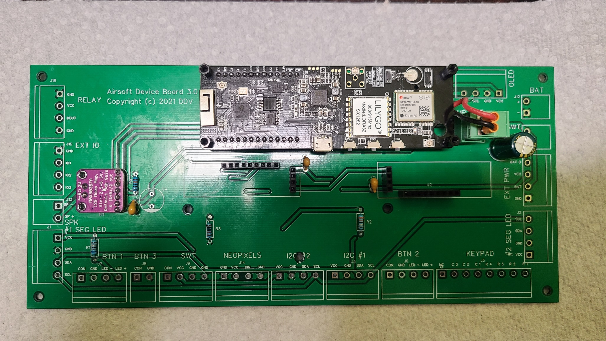

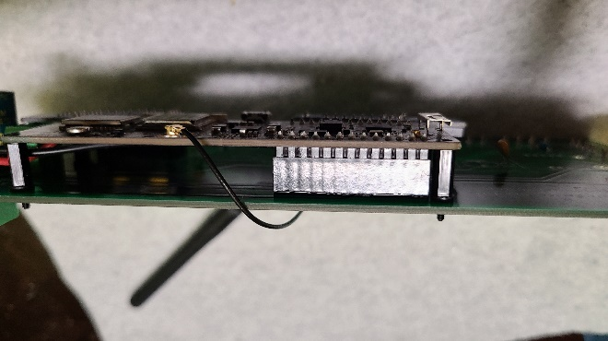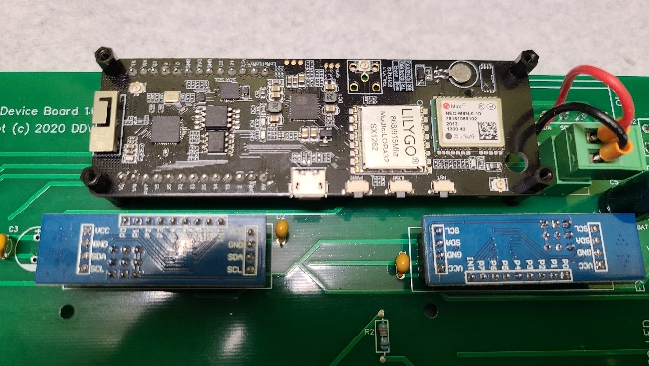

## Solder U4 MAX98357 I2S

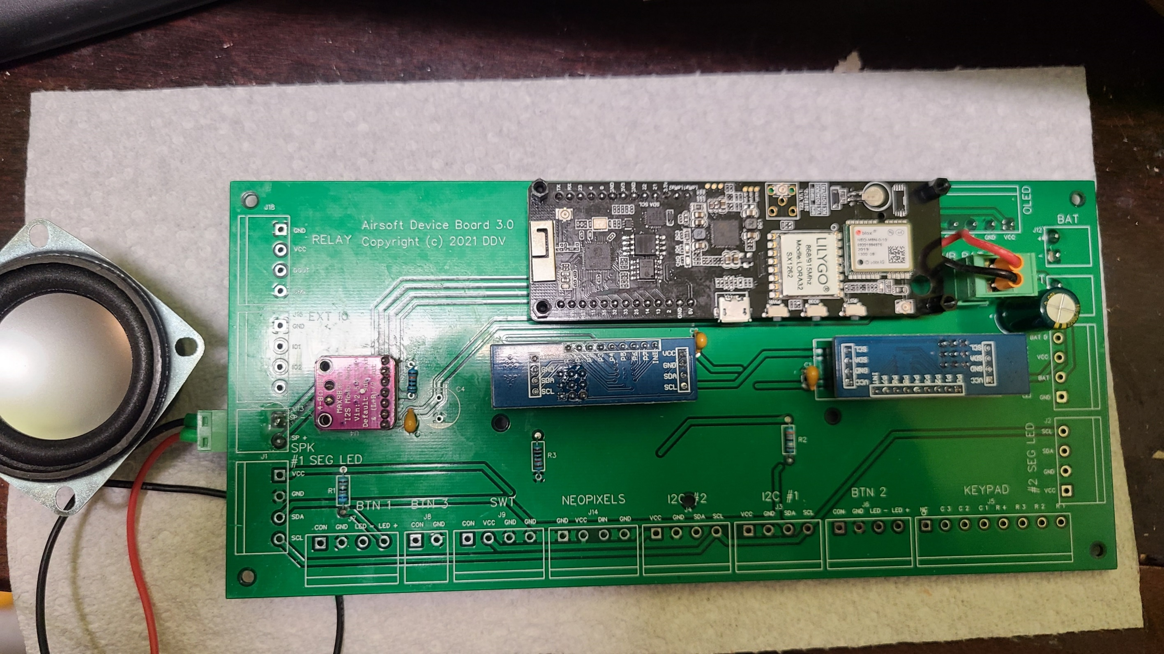

# Periphery

## Solder Battery Charger and Glue it on adapter.

Solder T-connector to battery input and output to main board. Glue charging board on adapter.

WARNING: Ground wire (black) to Main Board should going directly from T Connector but NOT from the charging board as pictured.

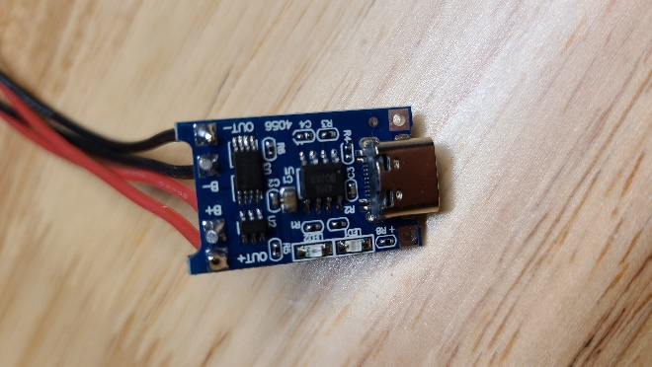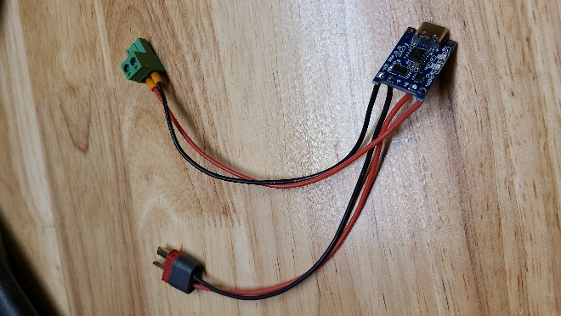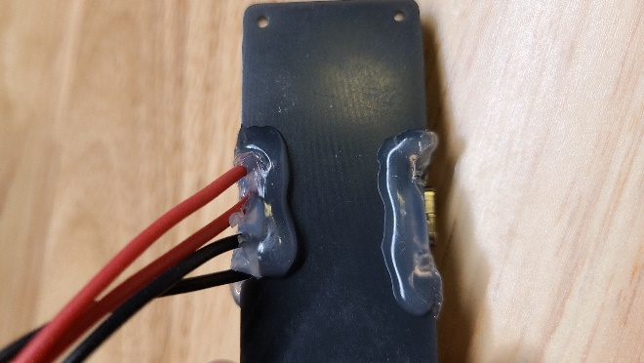

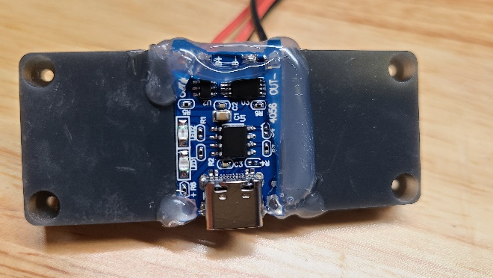

## Solder Power switch

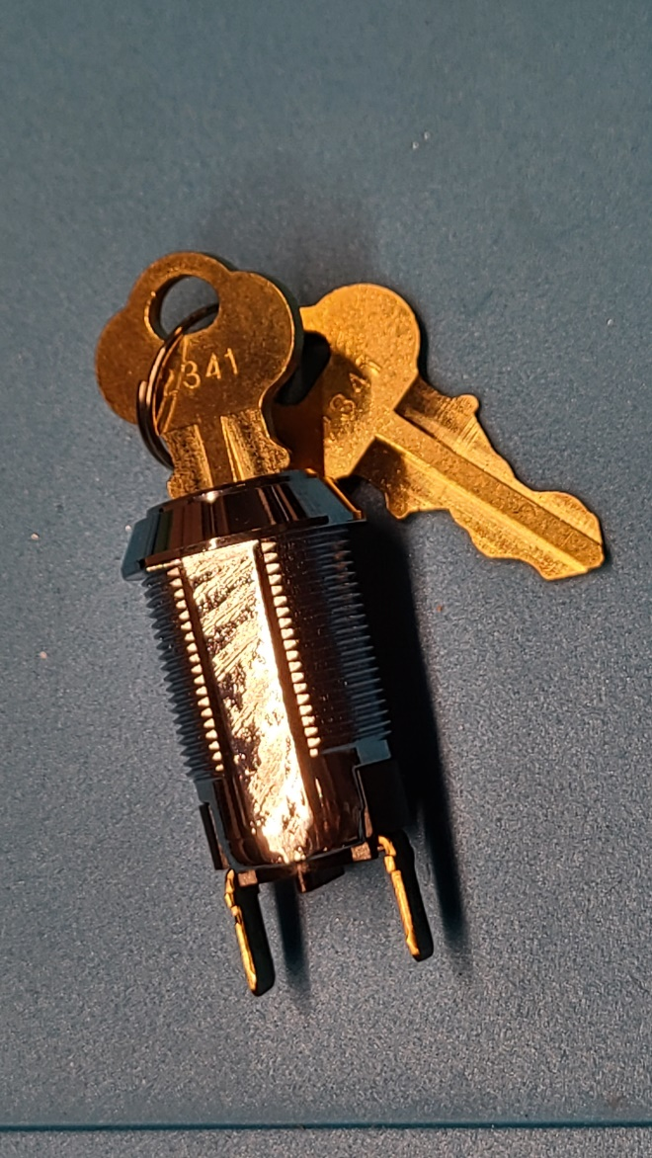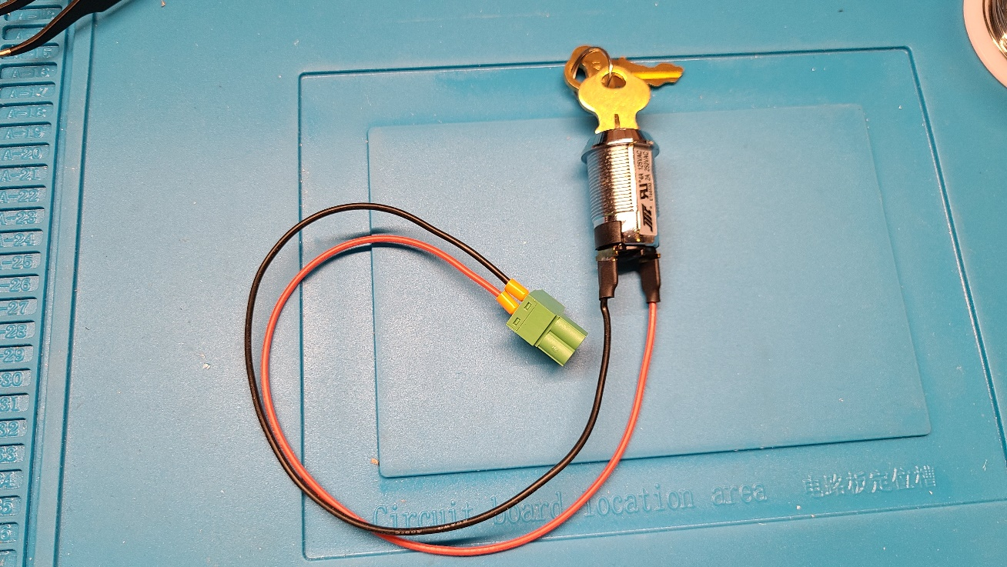

## Solder OLED screen

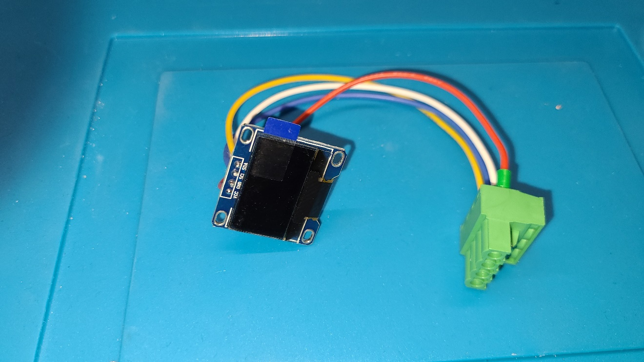

## Attach Green button

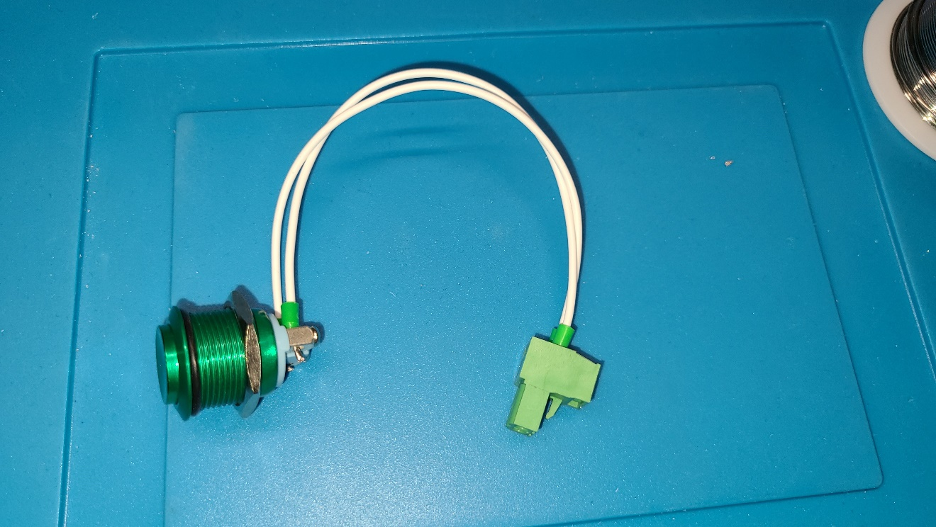

## Solder Red & Blue LED buttons

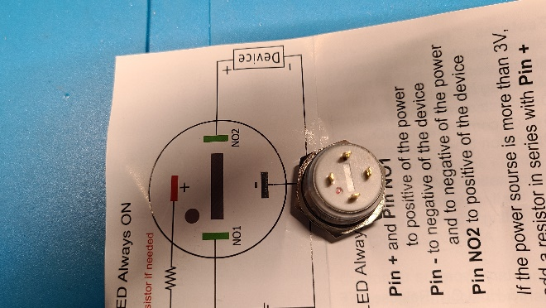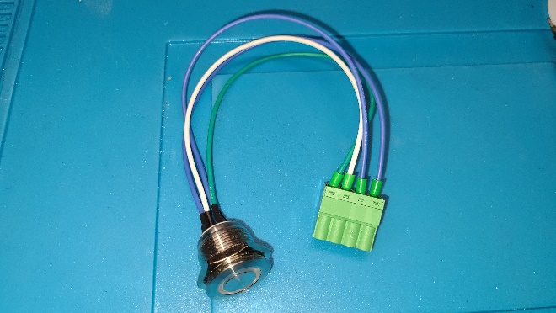

## Solder Switch

OFF pin is Ground. Right pin is VCC. Left pin is output. Internal LED connected to OFF pin and output. In OFF position output not connected and grounded via R3 pull down resistor on main board, LED is OFF. In ON position output connected to VCC and LED is on.

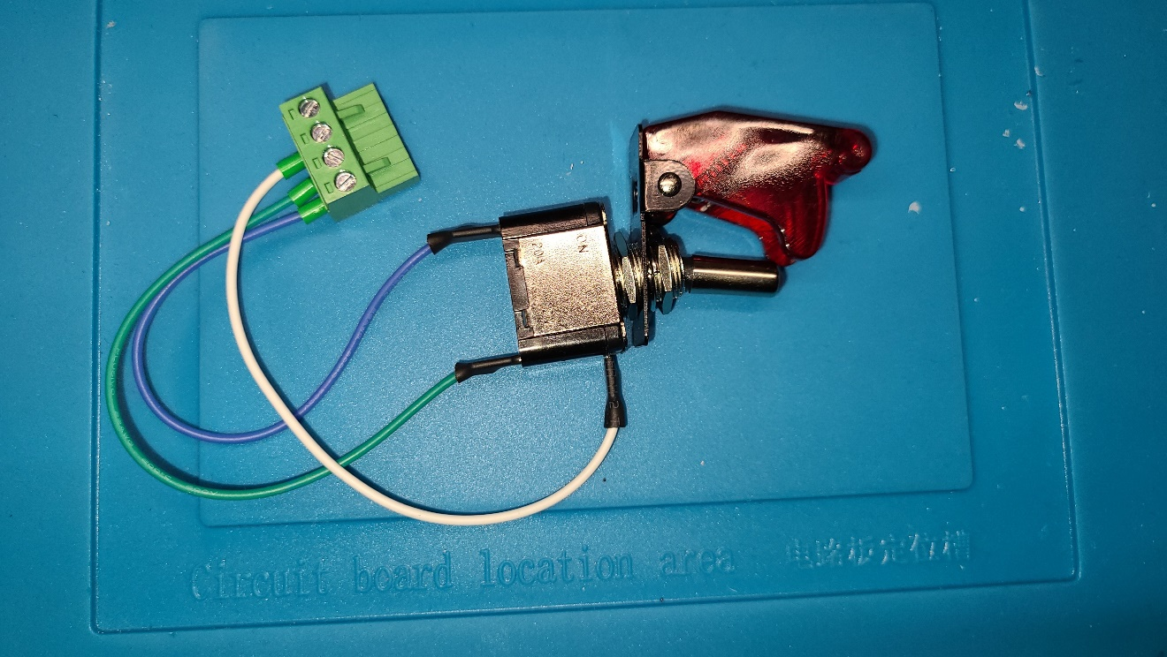

## 7-Segment Displays RED & BLUE

Solder displays to I2C board.

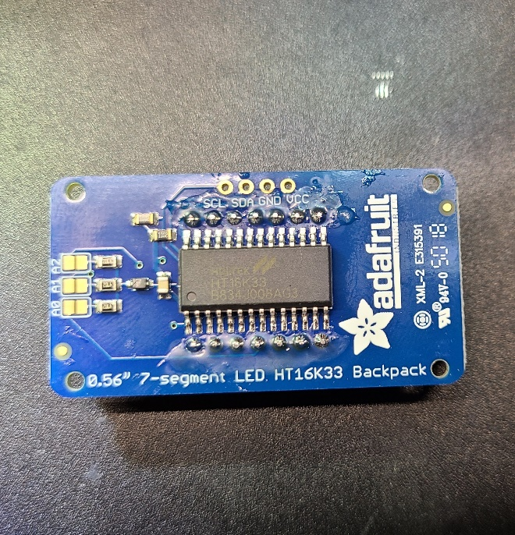

Then solder I2C wires.

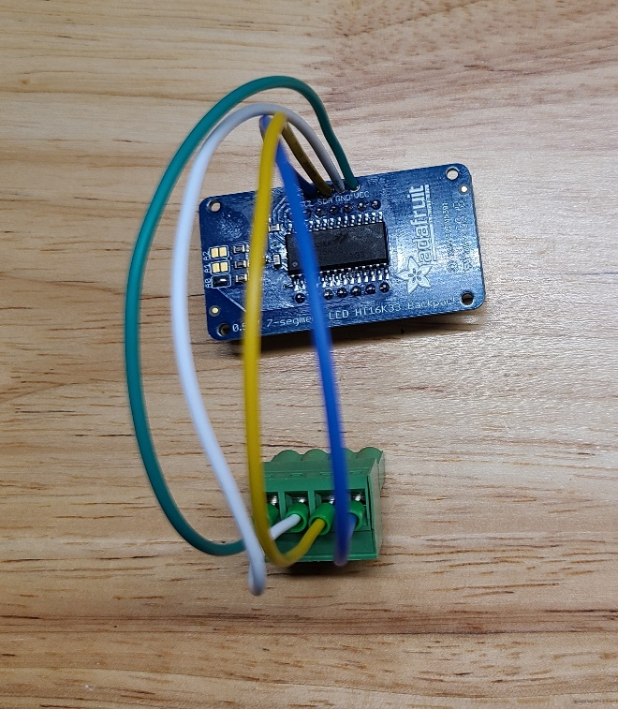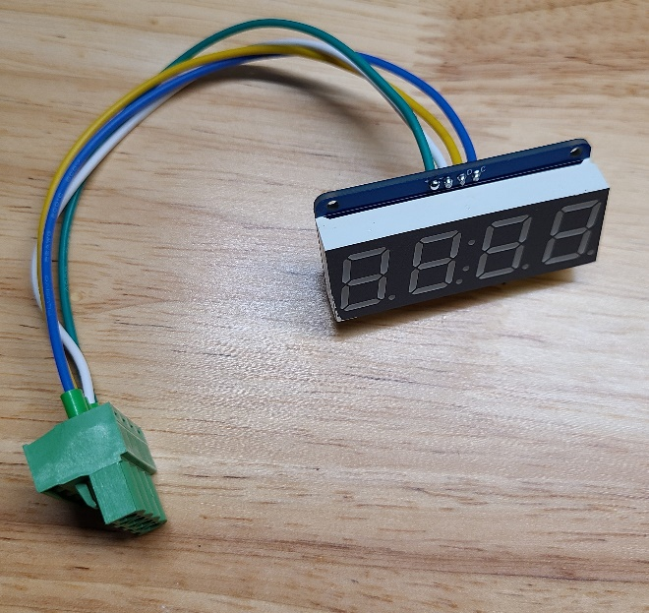

Solder A0 pad on BLUE display.

## Neopixels

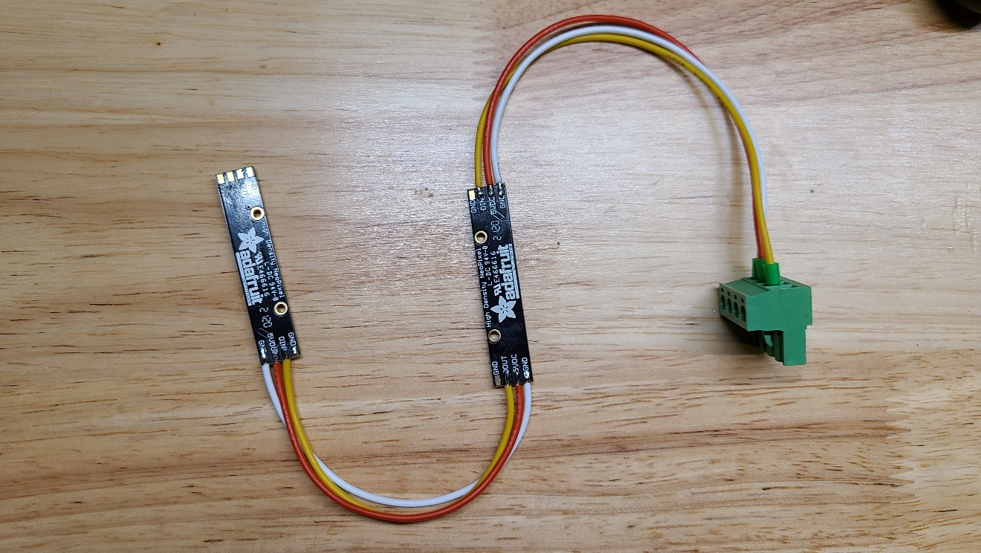

## Keypad

3x4 Matrix Keypad pinout: 1-7 from left to right C2 R1 C1 R4 C3 R3 R2

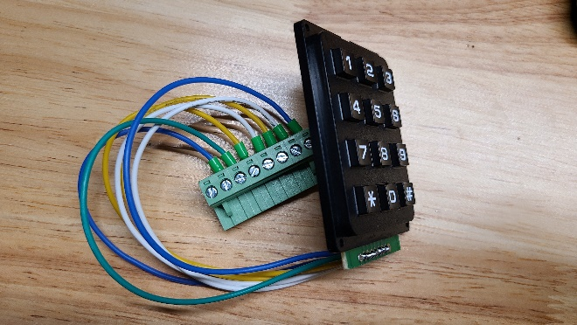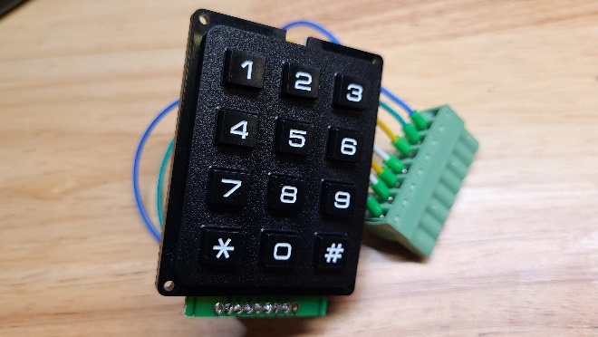

## Battery Holder

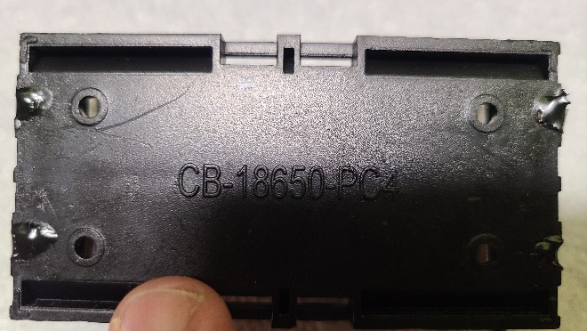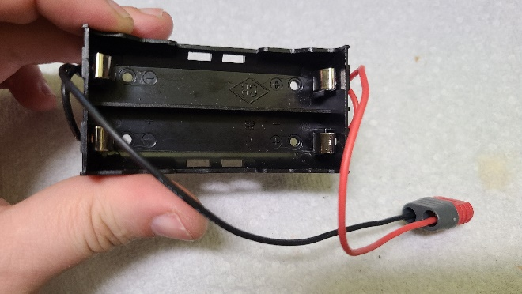

# Top Panel

## Cut top panel from ¼” dark brown Plexiglas

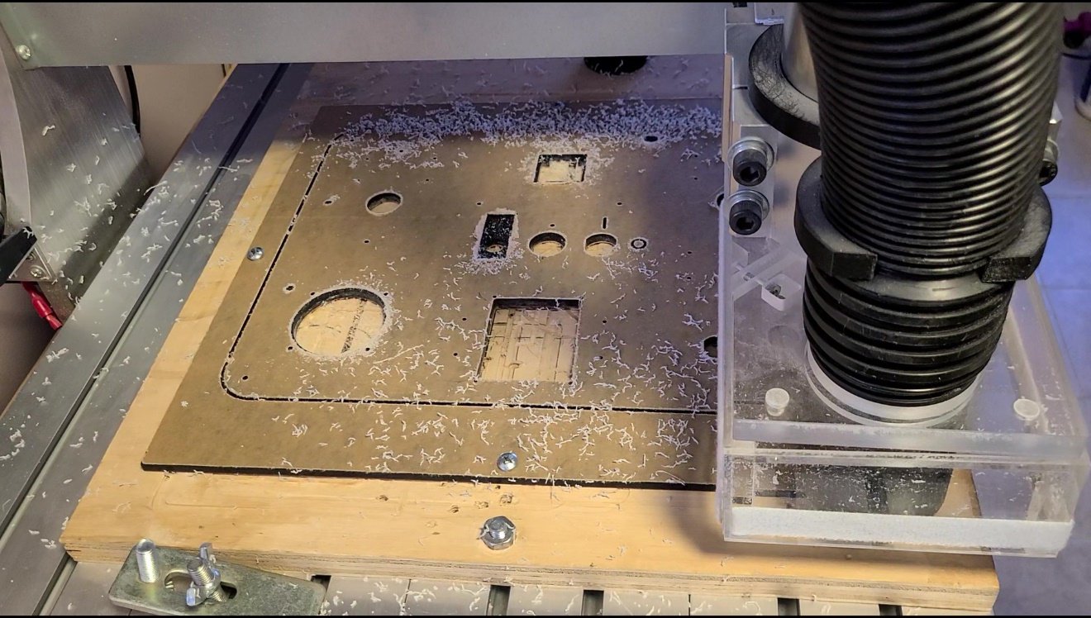

## Paint backside

Mask displays (RED & BLUE 7 Segments displays, Neopixels, Charging led on charging board) by masking tape. Paint backside of panel by airbrush in deep black color. Let it dry for 48h.

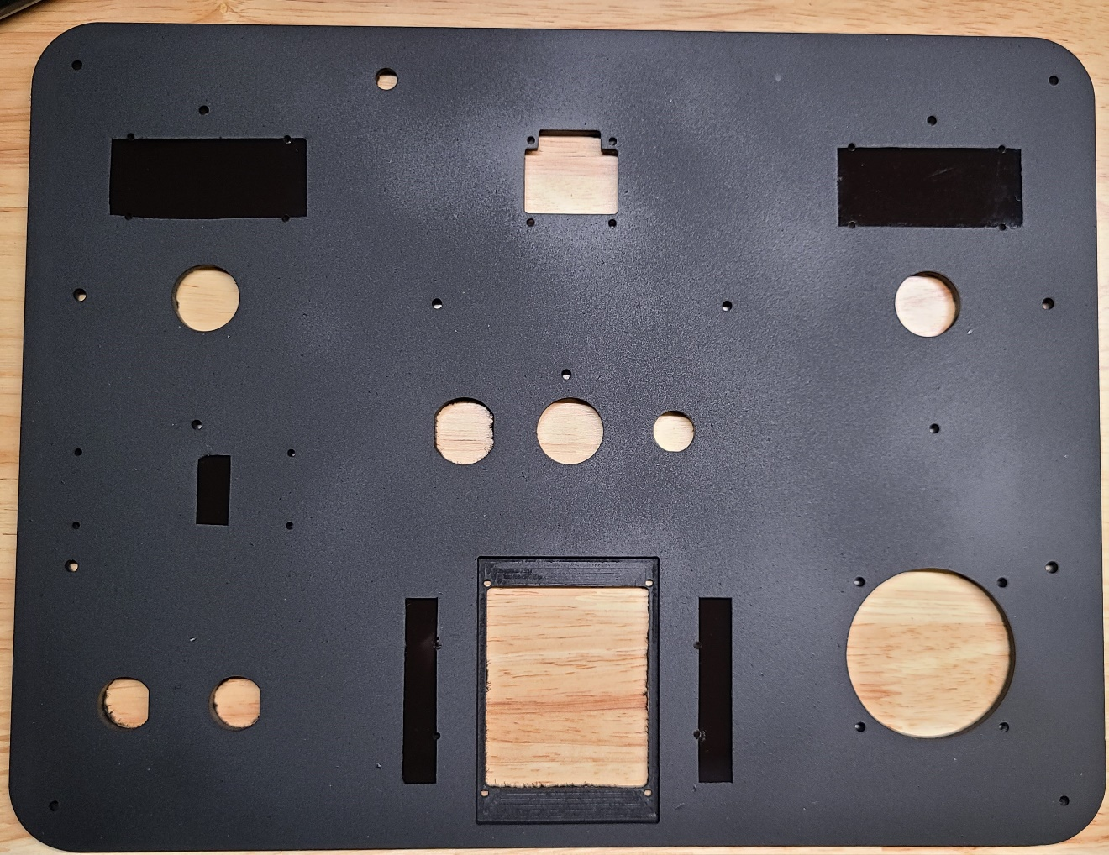

## Color the On and Off signs

Use acrylic paint or colored resin.

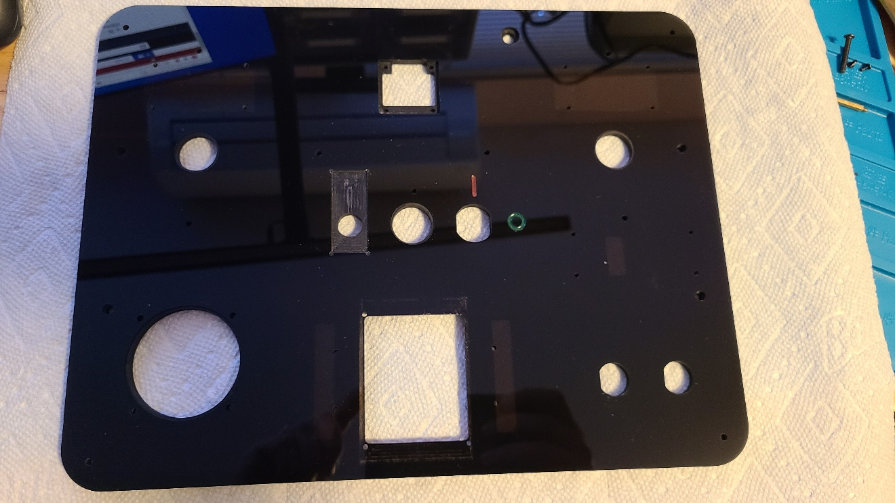

## Attach spacers to periphery

Attach periphery using M2 Nylon Hex Spacers.

Battery Charger board - 4xM2 6mm + 4xM2 10mm

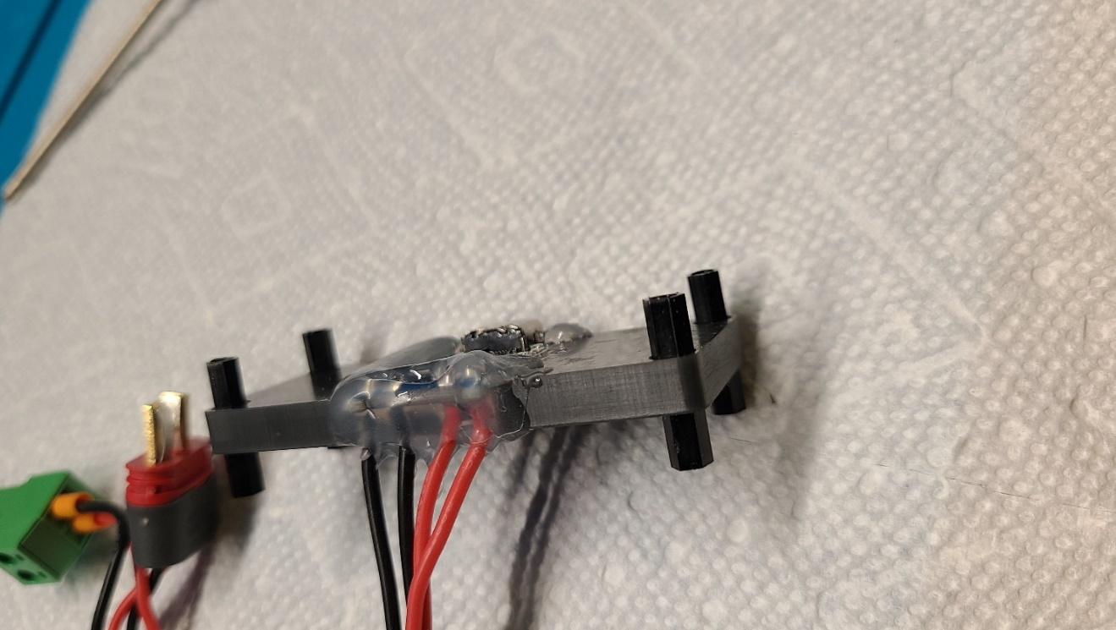

LEDs - 4xM2 10mm + 4xM2 any size as nuts

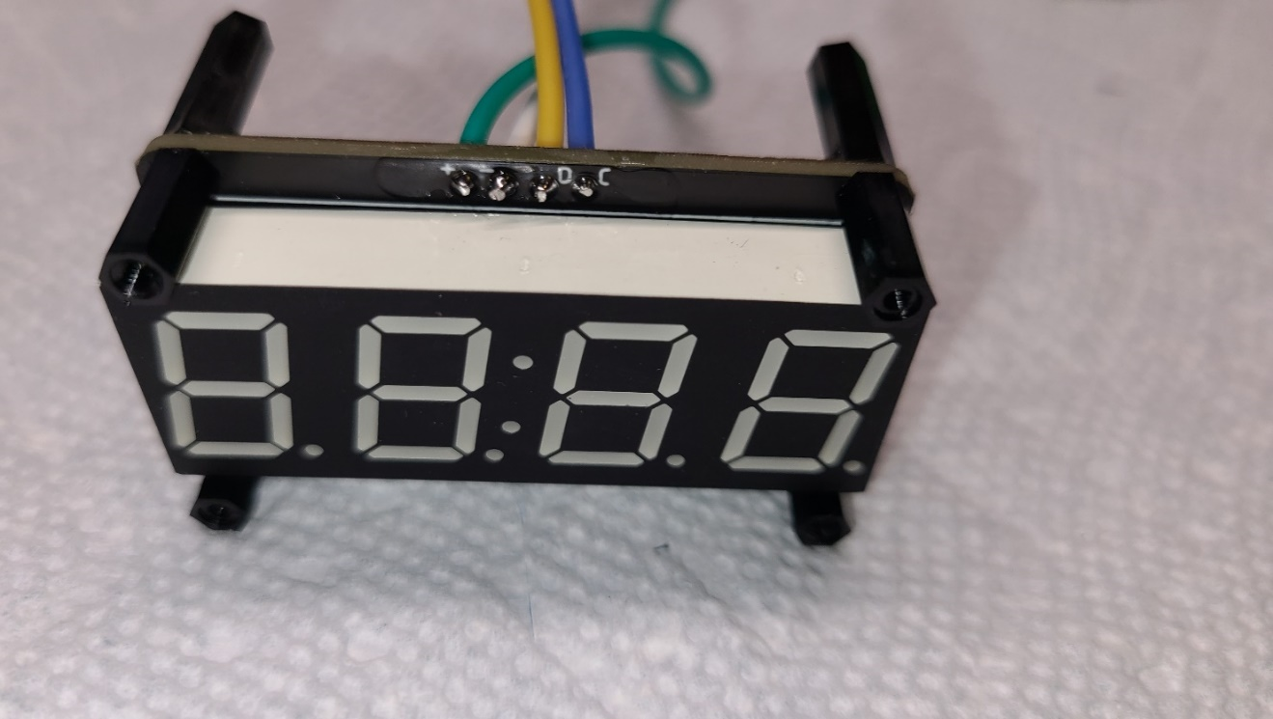

Neopixels - 4xM2 6mm + 4xM2 any size as nuts

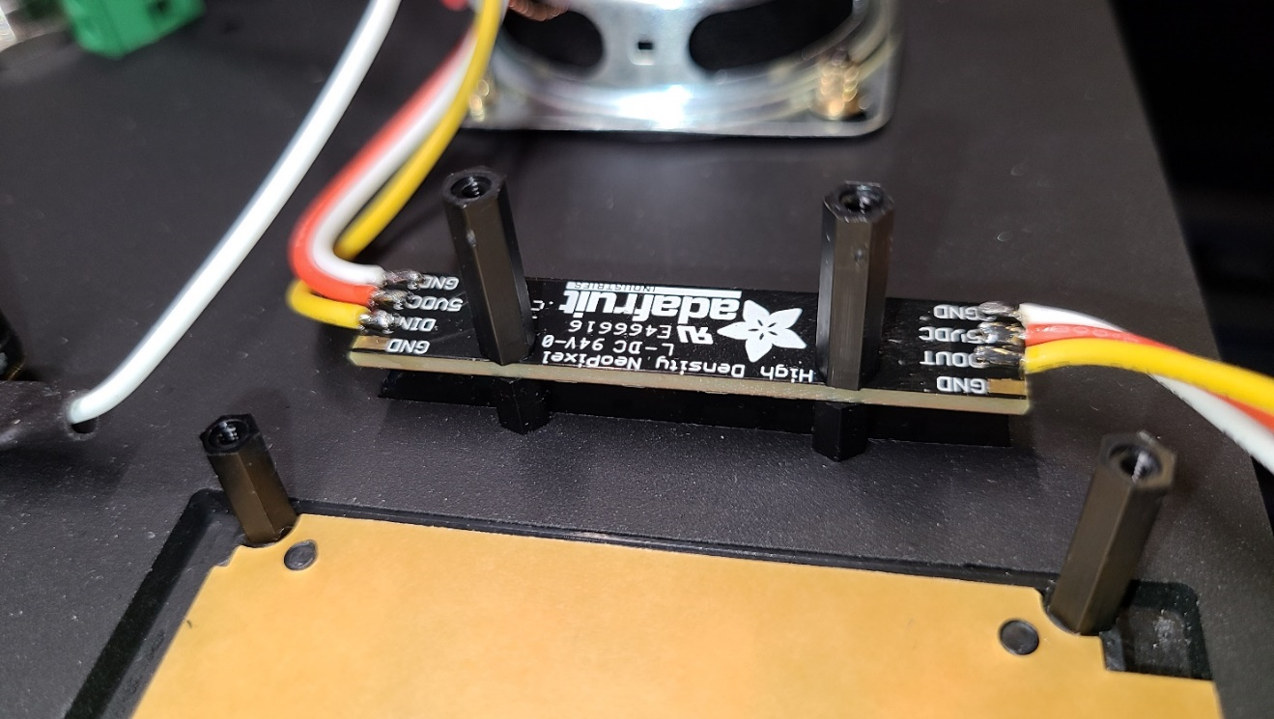

## Attach periphery to Top Panel

Attach speaker using M3 screws

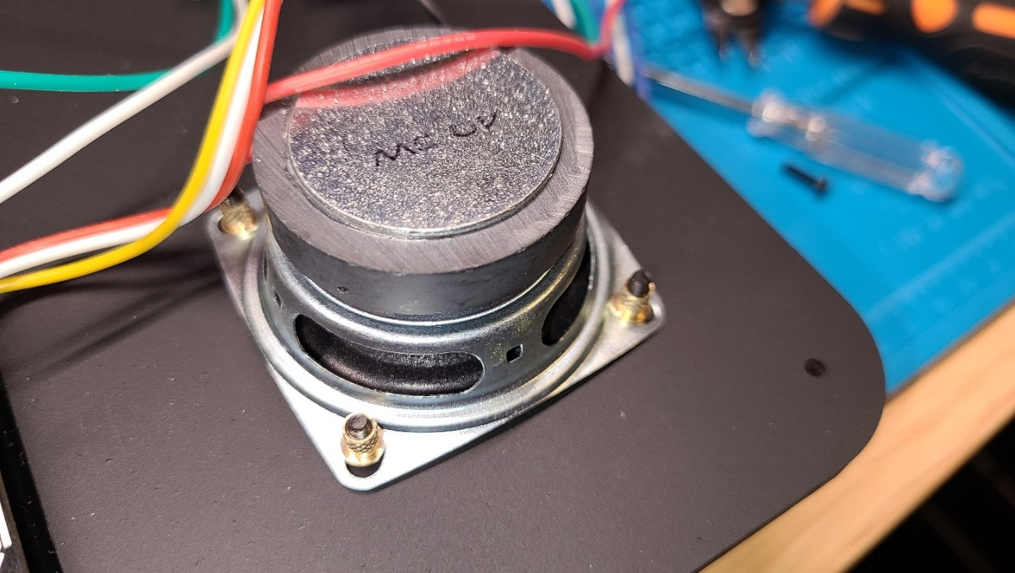

Attach Battery Charger board using M2 nylon screws

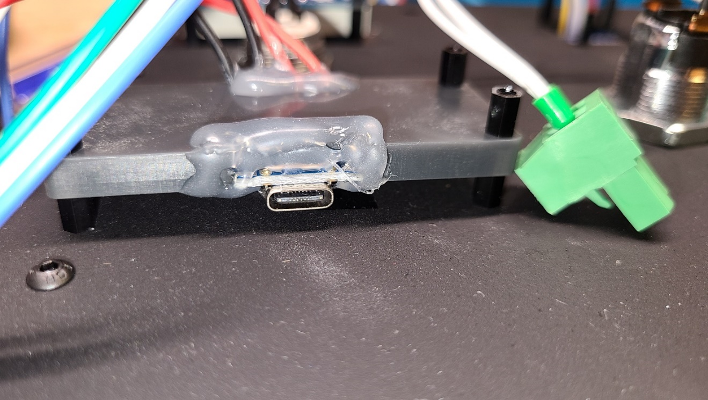

Attach LEDs using M2 nylon screws

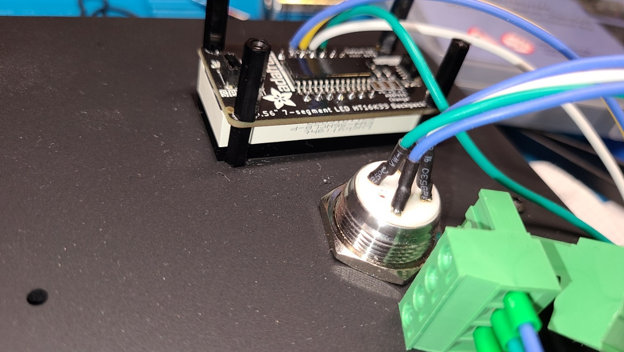

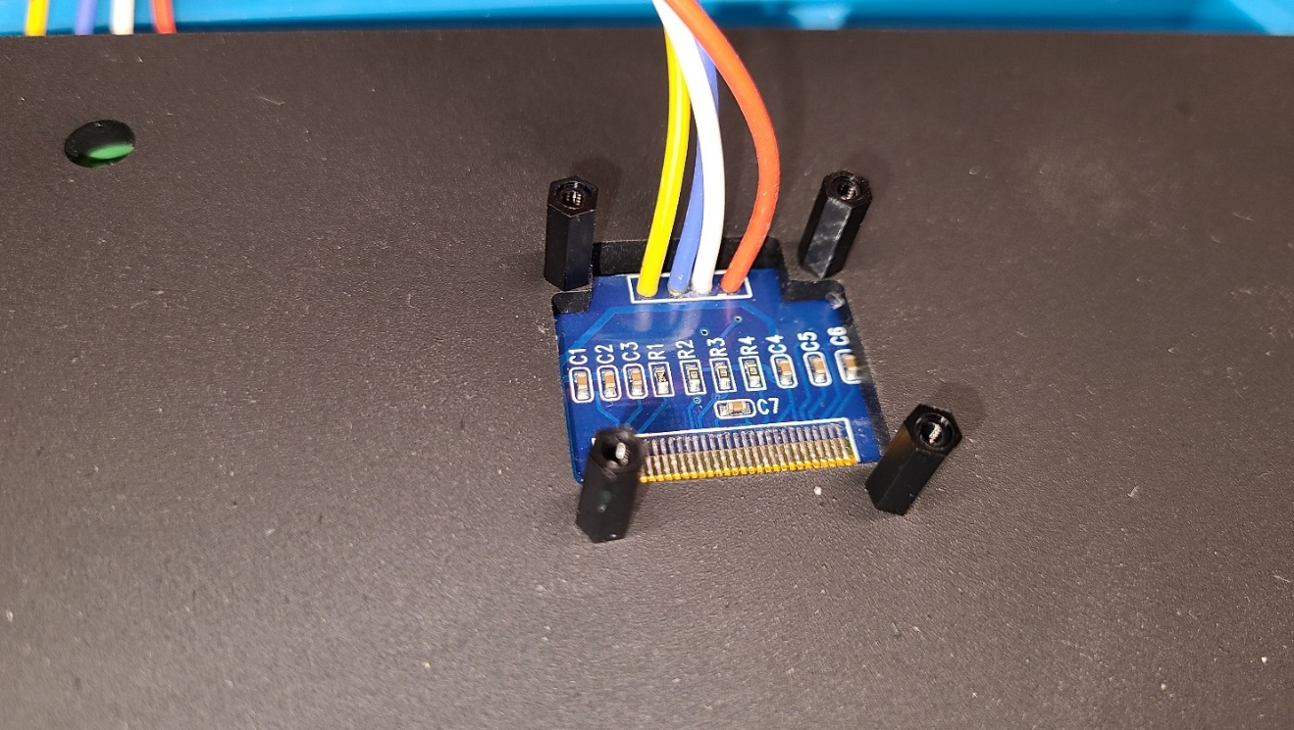

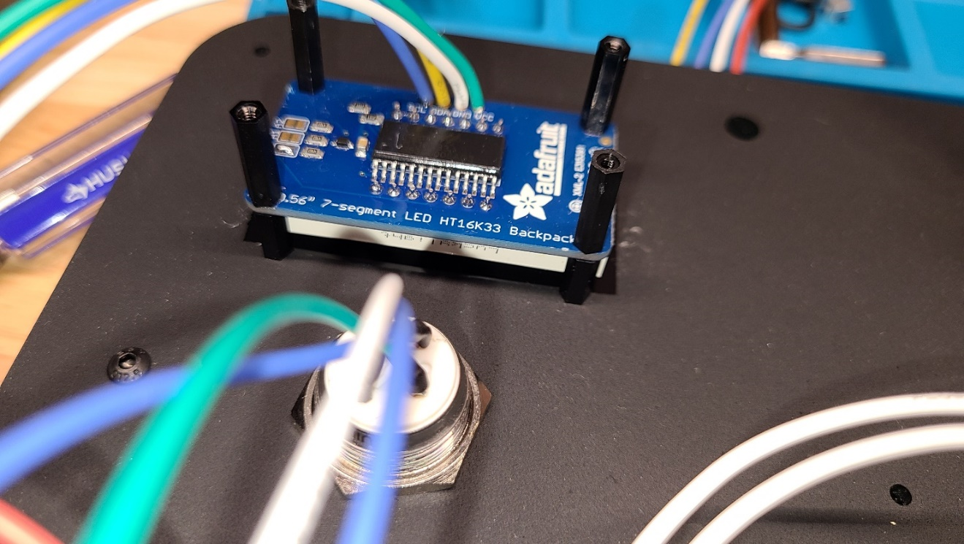

Attach buttons and switch

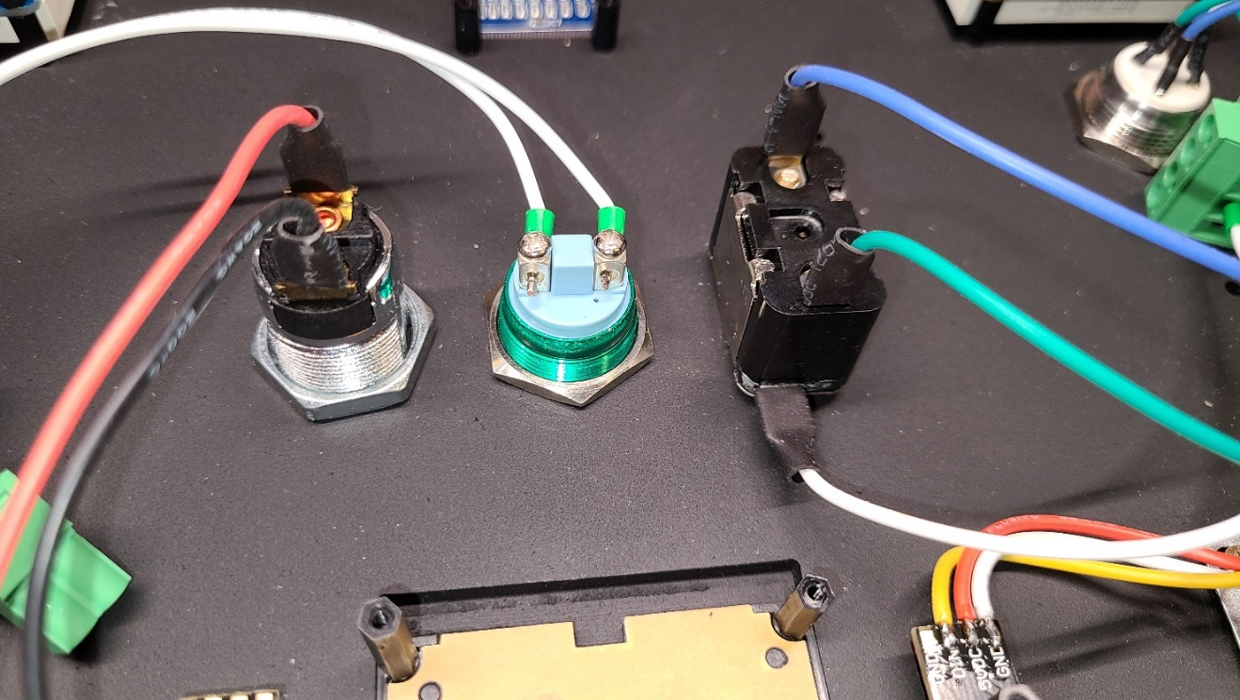

Attach Neopixels and Keypad using M2 nylon screws

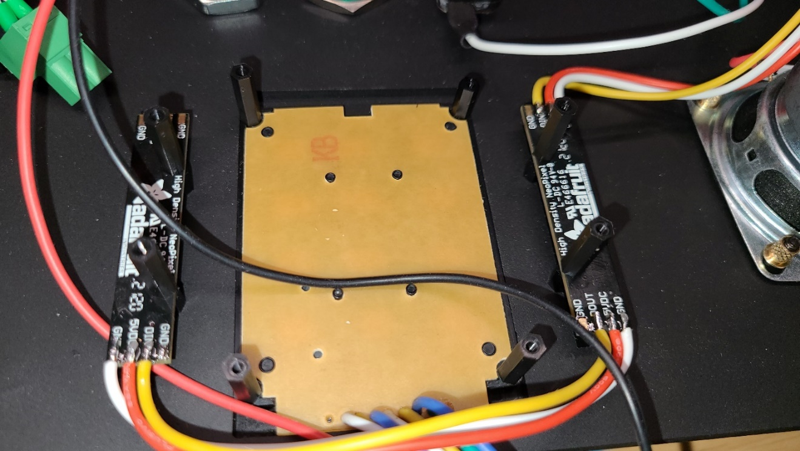

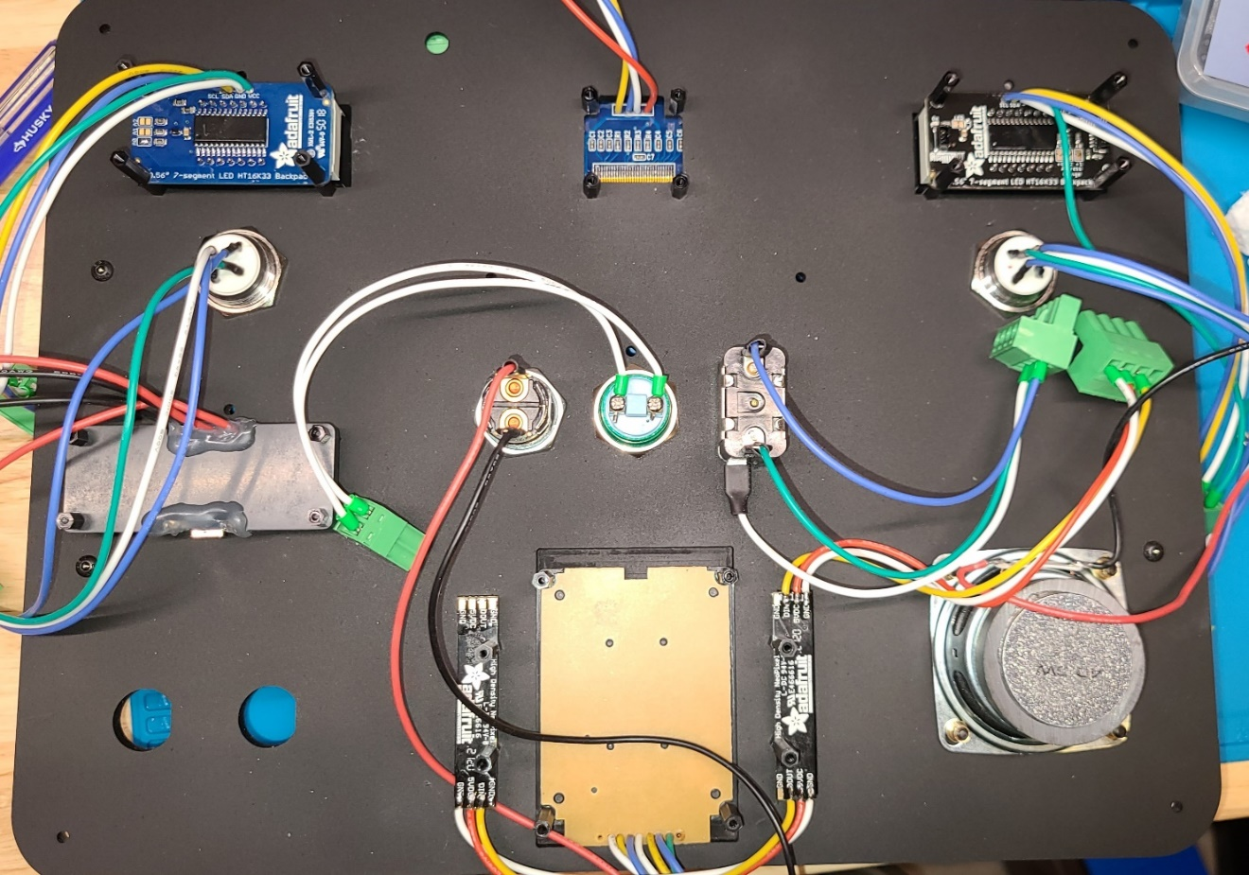

## Attach Main Board

Attach Main Board using 50mm metal stands

